Music Generating Using RNN

Israt Farhana (14101186), Samiha Tasnim (14301063), Tasnia Nobi (14302052)
Department of Computer Science and Engineering
BRAC University
Dhaka, Bangladesh

Abstract
We have studied and analyzed the problem of generating monophonic music in figurative sequences with the representation of a conventional piano-roll. We have worked with an actual framework that holds the issue as a dual-classification instead of one along with a multimodal probability distribution. For our research we have used LSTM-Recurrent Neural Network. This architecture provides the adaptivity for optimizing performance both for melodic and harmonic prediction (separately and together). Finally, this approach has generated original music sequences. Additionally, we tested this on the Nottingham dataset and attained an accuracy of more than 77%.
Keywords
Music Generating, LSTM, Recurrent Neural Network.

- Introduction

Background: Many spontaneous activities like music, speech or motion etc. are inherently sequential. Depending on this fact, modeling them on a basis of temporal sequence has dominantly become a significant area of neural network research. Among many, one prime example of sequential data is musical sequence generation is one of the most important as it is distinctly depended on temporal relations. For instance, in a musical piece, if a pattern is used once, it is highly probable that that pattern or theme might reoccur after several measures and the recurrence number might be extensive throughout the whole piece. To model these sorts of data, RNN [10] or Recurring Neural Network is vastly used. This network contains a memory which stays internally and learns over inconsistent but sequential data to use them for later purpose. Basically, it models the arbitrary data to place them in a good fit where necessary. To train the dataset, mostly known methods are gradient based optimization techniques such as Stochastic Gradient Descent. However, even though this is efficient, challenges like Exploding Gradient Problem [3] are faced while using this procedure. In solution to that, Long-Short Term Memory (LSTM) cells [6] can be a fitting resolution to offset the problem. Given that LSTM cells have shown exceptionally outstanding results while solving Language Modeling Tasks [8], they can be considered as the ideal candidates for the job.
This is to note that this paper refers to only the examination of the timing and pitch information typically contained in a score or a MIDI file instead of signals or more complex acoustically rich audio waves.This is because we are focusing the Music Language modeling in a completely general piano-roll representation. Monophonic transcription will be the primary use case for these models which is basically the challenge of predicting the underlying notes of a monophonic signal without accessing the scores underlying. The dataset for Music Language models are trained in such a way that conditional probability notes are predicted to be played together in a time step when all of the time steps have occurred before it. An attempt to use a LSTM network was taken in early phase called Eck. et al [5] to assimilate the structure of monophonic blues music. This was also approached by Allan et. al [2] from using 1 Hidden Markov Models to learn over chord harmonization of the late composer J.S. Bach.
While working with high-dimensional sequences of music, a major issue to deal is the fact that they ar highly multi-modal. Characteristically, the probability of the appearance of a node is considerably modified with the occurrence of a note in a given time step with the other notes that may occur at the same time. A remarking paper can be mentioned in this context that oversees these complexity is BoulangerLewandowski et. al [4]. Here, Energy based models are introduced such as the Restricted Boltzmann Machine (RBM) which consists RNN-RBM where the output of an RNN is sent as input to the parameters of and RBM. This is used for predicting a multi-modal allocation. However, in this paper, we will be taking the approach of constraining the potential configuration of each time step instead of RNN-RBM. The purpose behind this is to pose the task as a classification problem by raising the idea of musical structure.

- Model

A description of the naïve RNN formulation is needed to be described as a pre-needed knowledge. We will be following the formulation proposed by Boulanger-Lewandowski et. al [4].

  - Cross-Entropy Formulation

An input Vector is defined at first to apply a sequence of musical sequences directly to an RNN. The input vector contains encoded discretized sequences in the form of time steps. It also contains 88 visible binary units to span the whole range of the piano from A0 to C8. The time step defined earlier is a hyper-parameter which should be reordered in an appropriate way so that the dataset is being learned over. If the time steps are set into a format of t-n…., t-2, t-1, t then prediction of the next time step can be achieved by passing the encoded melodic sequence into an RNN. To account for more than one notes potentially being activated at each time step, the loss function is used as log-likelihood cross-entropy.
The loss function applicable to a sequence of T number of time steps xt∈ R N is given below (1) where f (xnt) is the output layer of the RNN for input xnt.
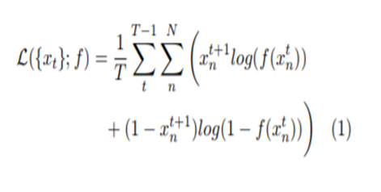
α here, is the melody coefficient, which tunes the importance of predicting the melody. If α reaches 1.0, the harmony will be ignored in the model and learn exclusively over the melody targets. On the contrary, if it becomes zero, harmony targets are learnt exclusively. This hyper-parameter comes up with a flexibility that is uniquely advantageous to this model of the cross-entropy formulation. For instance, the coefficient can be lowered to achieve sampling a harmonic backing in real-time to a improvised melody to attain the goals of their task.

2.1 Dual Softmax Formulation

The principal accomplishment of this paper is to separate each time step into discrete melody and harmony parts so that the problem can be posed as a two-class classification task. First part of the input vector xmt∈ RM, is a one-hot encoding of the melody note playing at time t. Another part xht∈RH is another one-hot encoding of the harmony class playing at the same time, which is basically a chord class e.g., C Major or G Minor. The concatenation of the melody and harmony segments forms the complete input vector which is xt∈RM+H. This is important to note that as only one melody and harmony classes are being played at a time, the model becomes more restrictive than the naïve case above. However, this particular limitation allows for the dual-softmax loss function (3) for both a sequence of T time steps xt∈RM+H along with melody and harmony aims mt∈RM and ht∈RH respectively.

Fig shows how duel softmax network works.
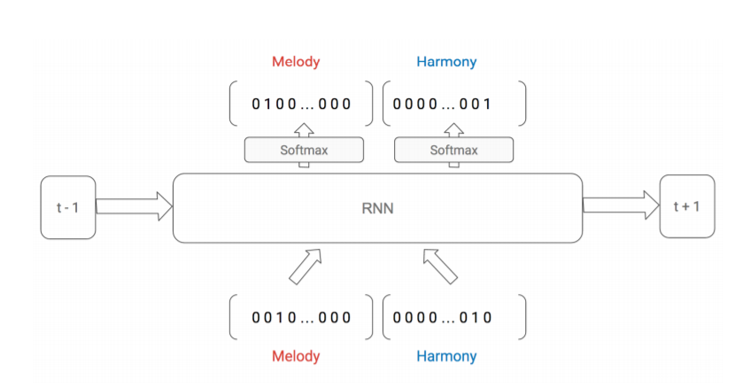

Figure 1: Dual Softmax Network.

- Experiments

  - Dataset

To test this model, a collection of 1200 folk tunes was used which is commonly known as The Nottingham dataset from [4]. However, not all of them did not fit properly. 203 (16%) of them were filtered as they were not fitting into the singular melody and harmony described earlier. With the rest of the 997, a 65/15/15 train, test and validation split were used for training all the described models. As the melodic sequences were needed to be discretized a time step of one-sixteenth note was applied (Boulanger Lewandowski et. al [4] uses a twice as long time3 step of one eighth note). This length resulted an average sequence length of 516 with 3588 as maximum. An open source music library called The Pythonmingus [7] was used to parse the harmonies into 31 chord classes and 1 class with the representation of harmony rest. Similarly, the range of melody note classes was 33 notes along with 1 class for representing melody rest. So the overall input dimension was 66 in this scenario.

  - Implementation

We have implemented the RNN by using a open source library named TensorFlow library [1] provided by google. l hidden layers with k LSTM cells each were used to implement this network along with one output dual-softmax layer. We have trained our network using minibatch stochastic gradient descent with RMSProp learning scheme [9] with a learning rate of 0.004 and a learning decay rate of 0.9. Back Propagation Through Time (BPTT) was truncated to a length of 128 times steps (a total measure of 8). While experimenting, hidden layers had 50% of dropout probability whereas 20% was applied to the input layers. As described in Zaremba et. al [11], only non-recurrent connection had been considered for dropout.

  - Results

We attempted several different hyper parameter combinations and found the test set accuracy shown in figure 1. One important thing to note is that the accuracy that we achieved is the classification accuracy which is not the same as the accuracy metric computed in Boulanger-Lewandowski et. al [4].
For the purpose of evaluating the effect the melody coefficient (α), we trained several models using different values of coefficients on architecture of 1 hidden layer along with 100 LSTM units.
Fig 2 shows Melody accuracy on the test set over several different melody coefficient values.
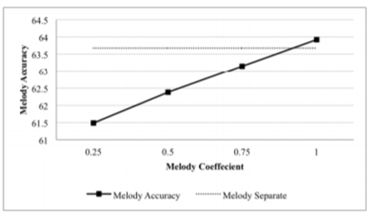
Figure 2: Melody accuracy on the test set over several different melody coefficient values.

Fig 3 shows Harmony Accuracy on the test set over several different melody coefficient values.
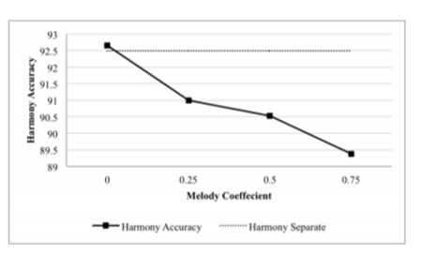

Figure 3: Harmony Accuracy on the test set over several different melody coefficient values.

Figure 3 refers to the results of these experiments. Each of the graphs contains a dashed line which that refers to a baseline which is created by training a model that only the harmony or melody vector as input. Here, we have avoided taking the whole concatenated input vector for technical reasons. model which is trained with a melody coefficient of 1.0. The very same thing stands for harmony baseline as well.

Table 1 shows the model accuracy.
Num Layers | 1 |  |  | 2
Hidden Size | 50 | 100 | 200 | 50 | 100 | 200
Testing Loss | 0.5896 | 0.5749 | 0.5343 | 0.5721 | 0.5575 | 0.5363
Accuracy (%) | 75.52 | 75.59 | 77.23 | 76.26 | 76.72 | 77.84
Table 1: Model accuracy over a variety of configurations

- Analysis

While comparing our results to Boulanger-Lewandowski et. al [4], we found it a bit problematic as there exists a variable label classification where we only have constant label classification. To sort this difficulty out, we could find no paper to compare the outcomes. Nevertheless, we found a qualitative method where we have generated an original music sequence by “Priming” the model with an initial few measures from a test sequence. We fetched the output and used the generated harmony and melody notes as the input of the next time step.
While experimenting the melody co-efficient, the verified an intuition that a higher melody coefficient corresponds to higher melody accuracy and lower coefficients results in lower accuracy. However, there is a minor drawback in the model which can be identified for Figure 2 and 3. Even though the accuracy level is quite high, the baseline points that the performance gain is very low, only 0.25% better for melody and 0.16% better for harmony. Given that the input level is very promising for predicting correct notes during the melody, the performance should be more significant. This should work in a vice versa way. For instance, the melody note C is more likely to be played than C# if the active harmony class is C Major.
Fig 4 shows a training graph.

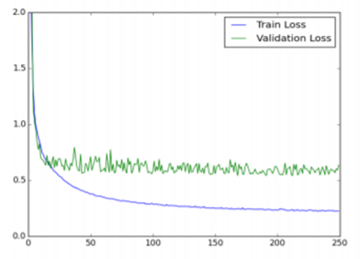

Figure 4: Training graph for a model with 2 hidden layers and 200 hidden units, using a dropout of probability 0.5 for the hidden layers and 0.8 for the input layer.

Over fitting might have caused the issue described above which also was encountered while training every model throughout this project. Even after performing extensive hyper parameter search over enormous dropout values, most of the time the training graphs reached a point where validation loss became noisy and no decreasing on average (Shown in Figure 4). If we could use a smaller input vector, it would reduce the overall count of parameters and lessened the effect of over fitting.

- Future Work

Firstly, our target would be to solve the complication of over fitting by implying other methods than dropout. In that case, a possible step would be finding a larger dataset than Nottingham. Another alternative can be synthetically producing an arbitrarily large musical dataset by originating permutations of chords progressions and playing melodic scales based those harmonic classes.
Moreover, we would also focus exploring different architectures based on the dual-softmax model. Regarding that, a notion is to place more separate hidden layers of melody or harmony or both. This has to be done before concatenating or element wise multiplication of them into a combined hidden layer. Figure 2 and 3 suggested this concept as may be the model benefits from learning separate abstractions of inputs before combining them. Also, we have one more idea to implement that combining more than two instruments together for an n-softmaxarchitecture. Here, a separate target for each instrument of an orchestral composition can be brought to mind as an example.

- Conclusion

This project helped us learn a lot about machine learning and artificial intelligence. We observed how a neural network works and how easily can predict and generate something new given a proper dataset only. It is amazing how technology has made everything possible that is also, with such ease. We have only collected a collection of piano tones and with the help of RNN we managed to generate a whole new set of tones. We can easily use this to generate different types of musical tunes and maybe someday we will be creating songs using AI.

- Acknowledgment

We would like to thank Dr. Iftekharul Mobin and Dr. Mohammad Zavid Parvez for helping and supporting us. We are grateful that we took this CSE422 course and they were our supervisors in the labs and taught us everything we know about machine learning and Artificial Intelligence.

- References

- TensorFlow: Large-scale machine learning on heterogeneous systems, 2015. Software available from tensorflow.org.
- Allan, M., and Williams, C. K. Harmonising chorales by probabilistic inference. Advances in neural information processing systems 17 (2005), 25–32.
- Bengio, Y., Simard, P., and Frasconi, P. Learning long-term dependencies with gradient descent is difficult. Neural Networks, IEEE Transactions on 5, 2 (1994), 157–166.
- Boulanger-Lewandowski, N., Bengio, Y., and Vincent, P. Modeling temporal dependencies in high-dimensional sequences: Application to monophonic music generation and transcription. arXiv preprint arXiv:1206.6392 (2012).
- Eck, D., and Schmidhuber, J. Learning the long-term structure of the blues. In Artificial Neural NetworksICANN 2002. Springer, 2002, pp. 284–289.
- Hochreiter, S., and Schmidhuber, J. Long short-term memory. Neural computation 9, 8 (1997), 1735–1780.
- Spaans, B. python-mingus. https: //github.com/bspaans/python-mingus, 2015.
- Sundermeyer, M., Schluter, R., and ¨ Ney, H. Lstm neural networks for language modeling. In INTERSPEECH (2012), pp. 194–197.
- Tieleman, T., and Hinton, G. Lecture 6.5—RmsProp: Divide the gradient by a running average of its recent magnitude. COURSERA: Neural Networks for Machine Learning, 2012.
- Williams, R. J., and Zipser, D. A learning algorithm for continually running fully recurrent neural networks. Neural computation 1, 2 (1989), 270–280.
- Zaremba, W., Sutskever, I., and Vinyals, O. Recurrent neural network regularization. arXiv preprint arXiv:1409.2329 (2014)

